# 1. Introduction

## 1.1 Introduction of website/system:

The Time Table Generator is a sophisticated web-based application developed to revolutionize the lecture timetable scheduling process within educational institutions. It serves as an automated solution to the manual and labor-intensive task of creating and managing course timetables, aiming to optimize resource allocation, minimize conflicts, and enhance overall efficiency.

### Problem Definition

Traditionally, the process of scheduling lecture timetables in colleges has heavily relied on manual methods, consuming significant time and effort from administrators. This manual approach often leads to scheduling conflicts, inefficient use of resources, and difficulties in accommodating various constraints such as room availability, faculty preferences, and student course preferences.

While some colleges may utilize commercially available software packages for timetable generation, these solutions may not adequately address the unique requirements and constraints of every institution. As a result, there is a pressing need for a customizable and adaptable timetable generation system.

## Existing System

The existing system for the gym operates without a dedicated database management solution, relying on manual processes for data handling. Member information, enquiries, and financial transactions are documented on paper, leading to a host of challenges. Data retrieval and updates are time-consuming, prone to errors, and lack real-time accessibility. The absence of a centralized database makes it challenging to track membership details, monitor expenses, and generate comprehensive reports. Inefficiencies in managing member enrollments, renewals, and fee collections hinder the overall operational effectiveness of the gym. The decision to transition to a new gym project site is prompted by the need to replace these manual procedures with a robust database-backed system, providing automation, accuracy, and improved administrative control.

## Need and Scope of the System

The Time Table Generator system addresses the shortcomings of manual timetable scheduling by leveraging computerized algorithms and user-friendly interfaces. Its primary objective is to streamline the scheduling process, saving time and resources for administrators while ensuring that all constraints and requirements are met.

The scope of the Time Table Generator system extends beyond basic timetable generation. It encompasses features such as user authentication, category and subcategory management, staff and student registration, and comprehensive access to timetable information. By providing a centralized platform for timetable management, the system enhances communication and collaboration among administrators, teachers, and students.

**2.1 Objectives**

**2. Proposed System**

The objectives of the Time Table Generator system are multifaceted, aiming to address the following key goals:

* Automation: To automate the process of timetable generation, minimizing manual intervention and optimizing resource allocation.
* User-Friendly Interface: To provide a user-friendly interface for administrators, teachers, and students, facilitating easy access to timetable information and management functionalities.
* Constraint Satisfaction: To ensure that all constraints and requirements, such as room availability, faculty preferences, and student course preferences, are satisfied during timetable generation.
* Efficiency Improvement: To enhance efficiency in managing course timetables, saving time and resources for administrators and stakeholders.

**2.2 Requirement Engineering**

### Feasibility Study

Feasibility study is essential to evaluate cost & benefit of the Proposed system. This is very important step because on the basis of this; system decision is taken on whether to proceed or to postpone the project or to cancel the project. We first study existing system and identify all problems & Look Into three types of feasibility study, those are given below:

### Technical Feasibility:

* Evaluation of the technological requirements and capabilities needed to develop and implement the system.
* Assessment of available resources, including hardware, software, and development expertise.
* Consideration of scalability and compatibility with existing systems and infrastructure.

### Operational Feasibility:

* Analysis of how the system will fit into the current operational processes and workflows of the educational institution.
* Identification of potential operational challenges and constraints, such as staff training and user adoption.
* Examination of the system's ability to streamline operations, improve efficiency, and meet organizational objectives.

### Economic Feasibility:

* Cost-benefit analysis to determine the financial viability of developing and implementing the system.
* Estimation of initial development costs, including hardware, software, and personnel expenses.
* Calculation of long-term operational costs and potential return on investment (ROI) through time savings, resource optimization, and improved outcomes.

### Legal and Regulatory Feasibility:

* Assessment of legal and regulatory requirements relevant to the development and deployment of the system.
* Identification of potential legal risks, such as data privacy and security compliance, and strategies to mitigate them.
* Evaluation of intellectual property rights and any licensing or copyright considerations.

### Schedule Feasibility:

* Determination of the project timeline, including development, testing, and deployment phases.
* Identification of potential risks and dependencies that may impact the project schedule.

**2.3 Requirement Gathering**

Requirements for the Time Table Generator system were identified through comprehensive interactions with stakeholders, including administrators, teachers, and students. Key requirements include:

* User authentication mechanism to control access to the system.
* Category and subcategory management for organizing courses and resources.
* Registration functionality for staff and students to access the system.
* Intuitive interfaces for viewing, editing, and managing timetables.

**2.4 Software Requirement :**

While working on the Project module, I have worked on various technologies like W3.CSS, HTML, JavaScript, PHP, MySQL, AJAX etc. The platforms that we used are WAMPP and XAMPP. A description of all these is given below.

### Introduction to W3.CSS.

* + W3.CSS is a modern, responsive, mobile-first CSS framework.
  + W3.CSS provides equality for all browsers: Chrome. Firefox. Edge. IE. Safari. Opera.
  + W3.CSS provides equality for all devices: Desktop. Laptop. Tablet. Mobile.
  + W3.CSS is standard CSS only (No jQuery or JavaScript library).
  + W3.CSS library is lightweight and easy to use.

### Introduction to HTML.

* + HTML stands for Hyper Text Markup Language
  + HTML is the standard markup language for creating Web pages
  + HTML describes the structure of a Web page
  + HTML consists of a series of elements
  + HTML elements tell the browser how to display the content
  + HTML elements label pieces of content such as "this is a heading", "this is a paragraph", "this is a link", etc.

### Introduction to JavaScript.

JavaScript, first introduced on December 4, 1995, often abbreviated as JS, is a programming language that is one of the core technologies of the World Wide Web, alongside HTML and CSS. As of 2022, 98% of websites use JavaScript on the client side for webpage behaviour, often incorporating third-party libraries.

* + JavaScript is the world's most popular programming language.
  + JavaScript is the programming language of the Web.

### Introduction to MySQL

MySQL is a fast, easy-to-use RDBMS being used for many small and big businesses. MySQL is developed, marketed, and supported by MySQL AB, which is a Swedish company. MySQL is becoming so popular because of many good reasons:

* + MySQL is released under an open-source license. So you have nothing to pay to use it.
  + MySQL is a very powerful program in its own right. It handles a large subset of the functionality of the most expensive and powerful database packages.
  + MySQL works on many operating systems and with many languages including PHP, PERL, C, C++, JAVA, etc.
  + MySQL works very quickly and works well even with large data sets.
  + MySQL is very friendly to PHP, the most appreciated language for web development. MySQL supports large databases, up to 50 million rows or more in a table. The default file size limit for a table is 4GB, but you can increase this (if your operating system can handle it) to a theoretical limit of 8 million terabytes (TB).

### Introduction to Wampp and Xampp

WampServer refers to a solution stack for the Microsoft Windows operating system,created by Romain Bourdon and consisting of the Apache web server, OpenSSL for SSL support, MySQL database and PHP programming language.

XAMPP is a free and open-source cross-platform web server solution stack package developed by Apache Friends, consisting mainly of the Apache HTTP Server, MariaDB database, and interpreters for scripts written in the PHP and Perl programming languages

**3. System Analysis**

**System Diagram**

## DFD

Represent the information that should be kept in mind when making a decision and this diagram. We are calculate how many entities are included in the system.

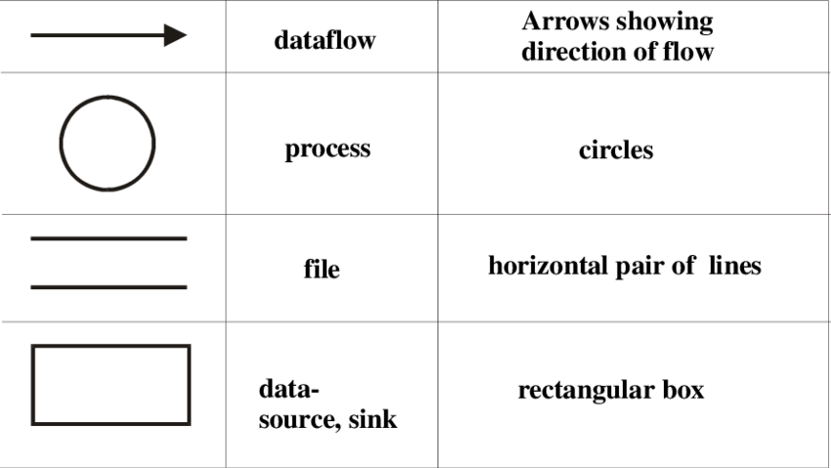

dfd

## ERD

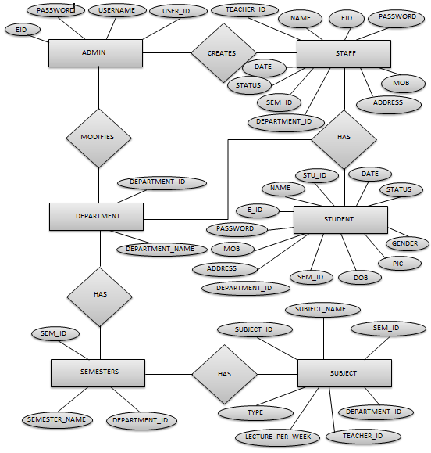

* 1. Site Map

**4. System Design**

## Database Design

* + - **Table Name : admin**

|  | **Column** | **Data Type** | **Constraints** |
| --- | --- | --- | --- |
| 11 | user_id | int(11) | PRIMARY KEY |
| 22 | user_name | varchar(50) | UNIQUE KEY |
| 33 | Password | varchar(50) |  |
| 44 | Eid | varchar(50) | UNIQUE KEY |

* + - **Table Name : contact_us**

|  | **Column** | **Data Type** | **Constraints** |
| --- | --- | --- | --- |
| 11 | id | int(11) | PRIMARY KEY |
| 22 | name | varchar(20) |  |
| 33 | email | varchar(20) | UNIQUE key |
| 44 | Subject | varchar(50) |  |
| 55 | Message | varchar(255) |  |

* + - Table Name : department

|  |  |  |  |
| --- | --- | --- | --- |
|  | **Column** | **Data Type** | **Constraints** |
| 11 | department_id | int(11) | PRIMARY KEY |
| 22 | department_name | varchar(50) | UNIQUE KEY |

* + - Table Name : semester

|  | **Column** | **Data Type** | **Constraints** |
| --- | --- | --- | --- |
| 11 | sem_id | int(11) | PRIMARY KEY |
| 22 | semester_name | varchar(20) |  |
| 33 | department_id | int(11) | UNIQUE KEY |

* + - Table Name : subject

|  | **Column** | **Data Type** | **Constraints** |
| --- | --- | --- | --- |
| 11 | subject_id | int(11) | PRIMARY KEY |
| 22 | subject_name | varchar(255) |  |
| 33 | sem_id | int(11) | UNIQUE KEY |
| 44 | department_id | int(11) | UNIQUE KEY |
| 55 | teacher_id | int(11) | UNIQUE KEY |
| 66 | lecture_per_week | int(11) |  |
| 77 | Type | enum('Theory','Lab') |  |

* + - Table Name : teacher

|  | **Column** | **Data Type** | **Constraints** |
| --- | --- | --- | --- |
| 11 | teacher_id | int(11) | PRIMARY KEY |
| 22 | name | varchar(50) | UNIQUE KEY |
| 33 | eid | varchar(50) | UNIQUE KEY |
| 44 | password | varchar(10) |  |
| 55 | mob | bigint(20) |  |
| 66 | address | varchar(1000) |  |
| 77 | department_id | int(11) |  |
| 88 | sem_id | int(11) |  |
| 9 | status | varchar(100) |  |
| 10 | date | date |  |

* Table Name : student

|  | **Column** | **Data Type** | **Constraints** |
| --- | --- | --- | --- |
| 1 | stu_id | int(11) | PRIMARY KEY |
| 2 | Name | char(50) | UNIQUE KEY |
| 3 | Eid | varchar(50) | UNIQUE KEY |
| 4 | Password | varchar(20) |  |
| 5 | Mob | bigint(20) |  |
| 6 | Address | varchar(1000) |  |
| 7 | department_id | int(11) |  |
| 8 | sem_id | int(11) |  |
| 9 | Dob | date |  |
| 10 | Pic | varchar(255) |  |
| 11 | gender | enum('f','m') |  |
| 12 | Status | varchar(50) |  |
| 13 | Date | date |  |

* + - Table Name : timeshedule

|  | **Column** | **Data Type** | **Constraints** |
| --- | --- | --- | --- |
| 11 | timeschedule_id | int(11) | PRIMARY KEY |
| 22 | department_name | varchar(20) |  |
| 33 | semester_name | varchar(20) |  |
| 44 | subject_name | varchar(20) |  |
| 55 | time | varchar(20) |  |
| 66 | date | varchar(20) |  |
| 77 | teacher_id | int(11) |  |

## Input Design

### Admin Login

**Path:** Time Table/Admin Login

**Description:** The page for admin login which gives access to the admin module



**Validation:**

On entering wrong data custom alert



### Staff Login

**Path:** Time Table/Staff Login

**Description:** The page for staff login which gives access to the staff module

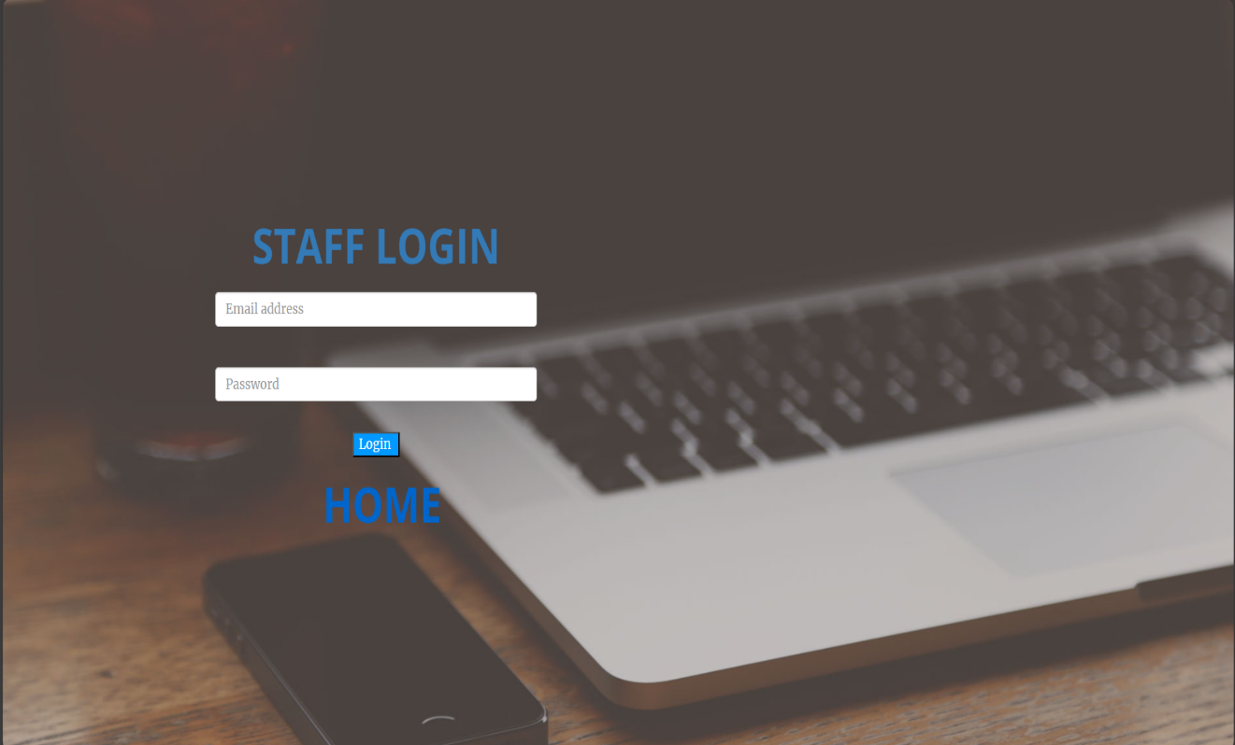

**Validation:**

On entering wrong data custom alert

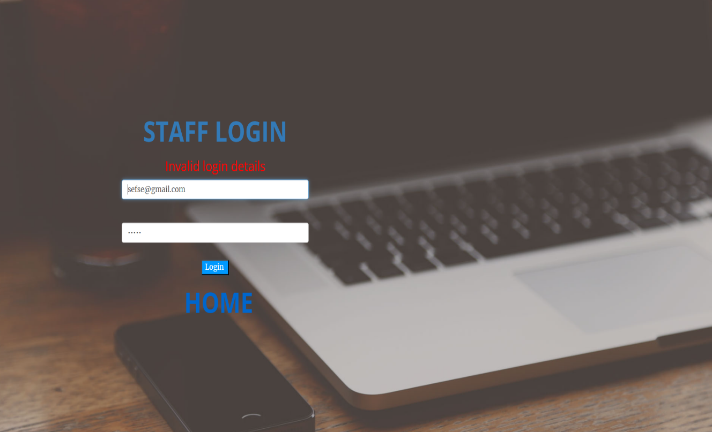

### Student Login

**Path:** Time Table/Student Login

**Description:** The page for student login which gives access to the student module

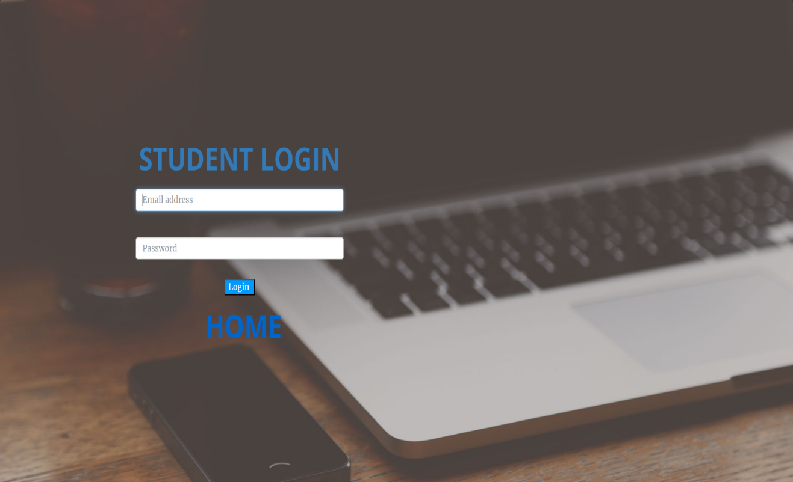

**Validation:**

On entering wrong data custom alert

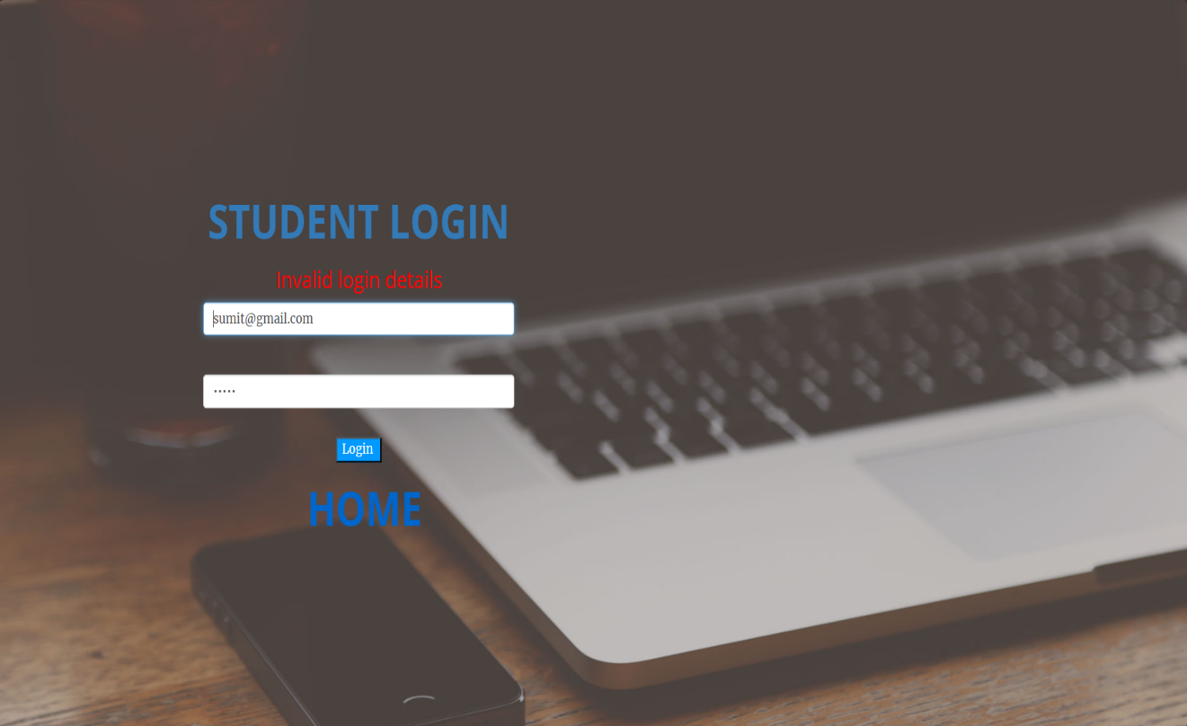

### Contact us

**Path:** Time Table/Contact us

**Description:** Contact us page for giving feedback, complaint, etc

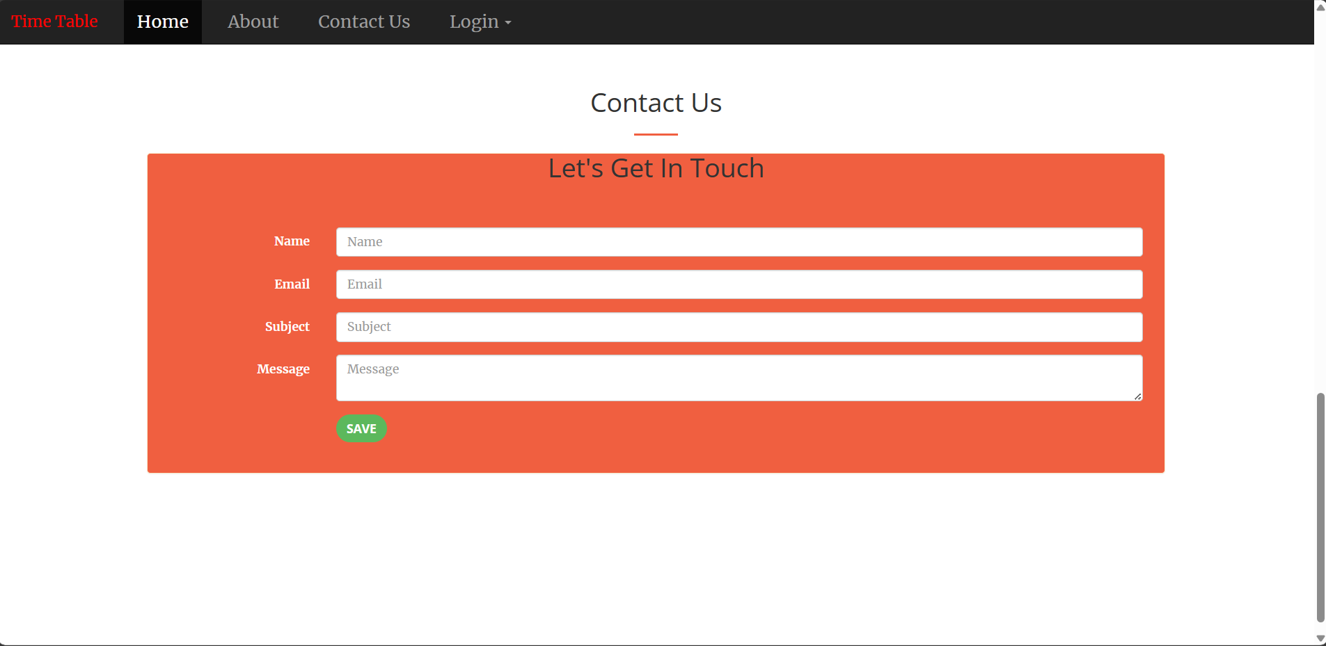

**Validation:**

On successful entering of data, custom alert

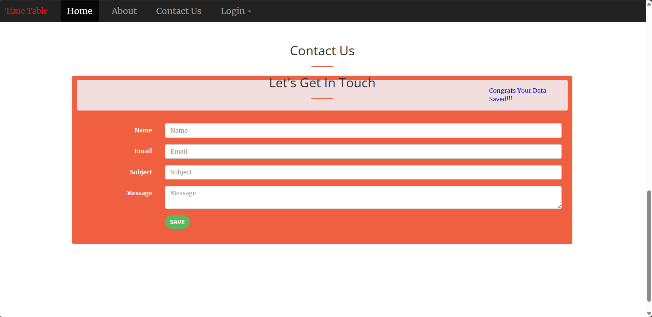

### Department

**Path:** Home/Admin/Department

**Description:** To add department and update department

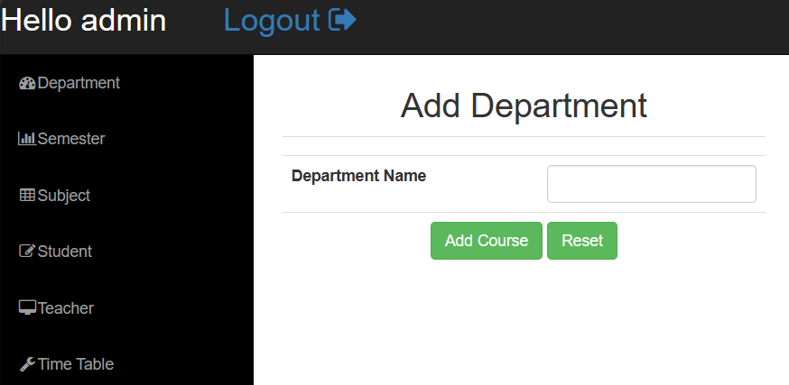

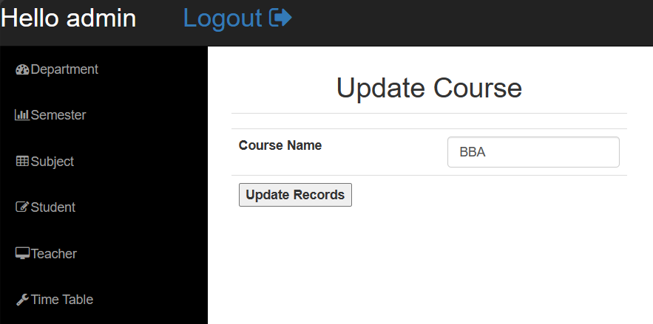

**Validation:**

After successful submission of data

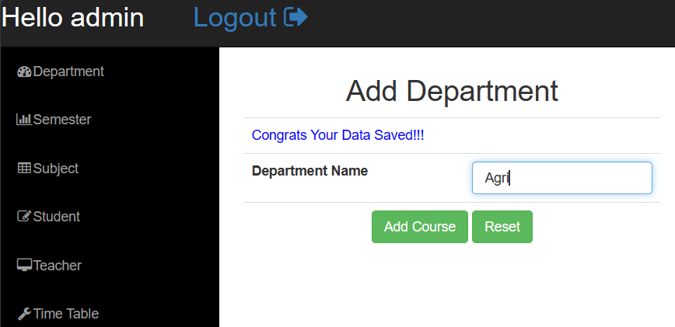 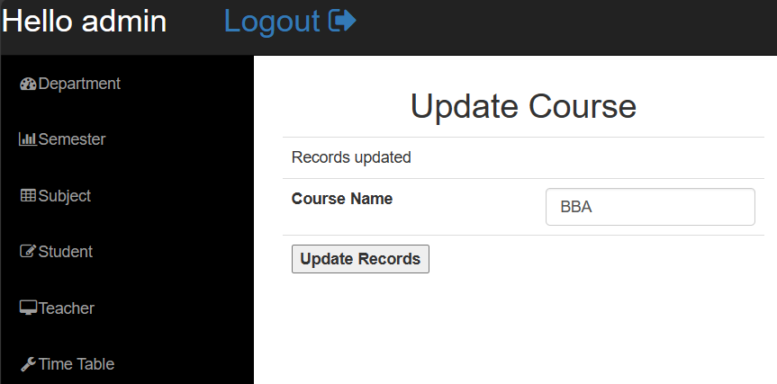

### Semester

**Path:** Home/Admin/Semester

**Description:** To add semester and update semester

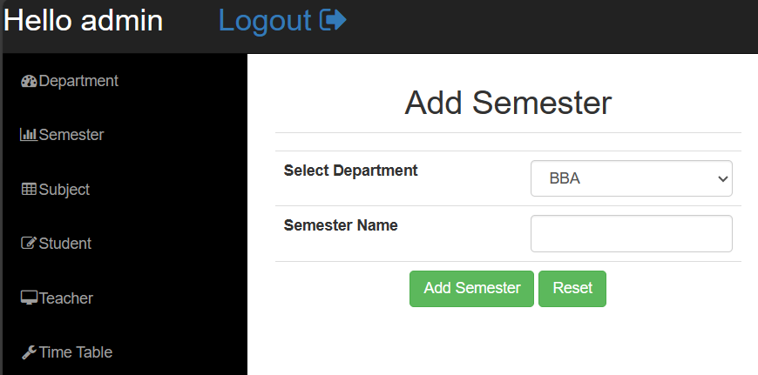

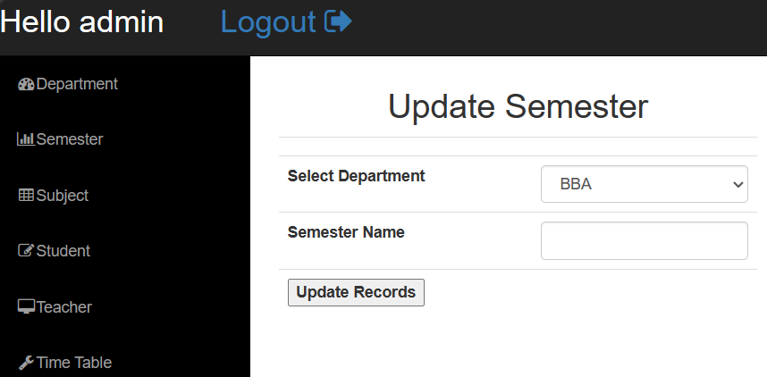

### Validation:

Alert on successful submission of data

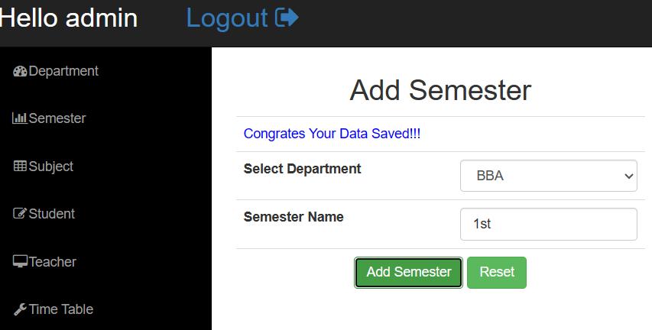 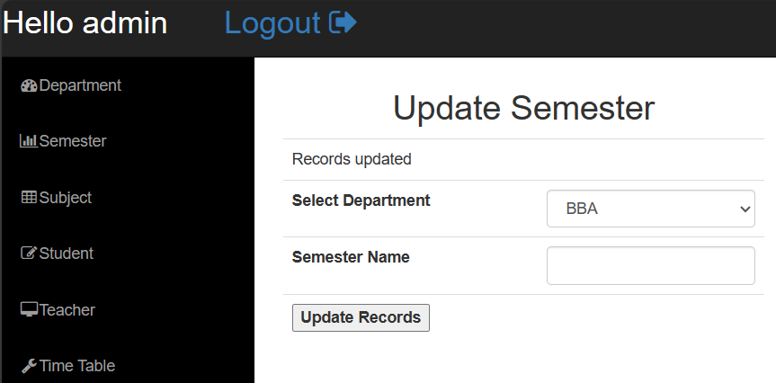

### Subject

**Path:** Home/Admin/Subject

**Description:** To add subject under department/semester and update it

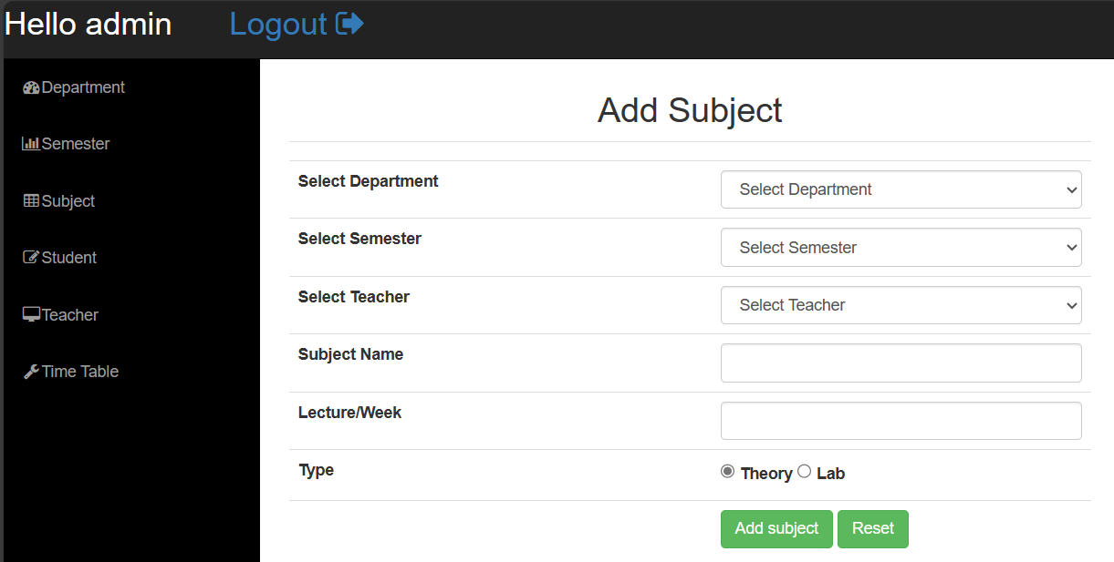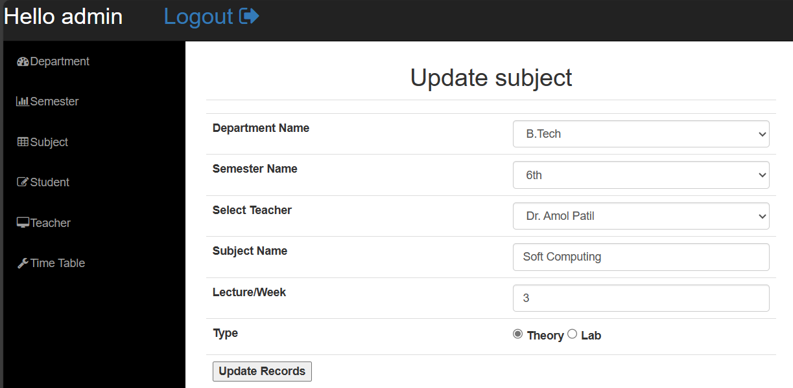

### Validation:

Alert on successful submission of data

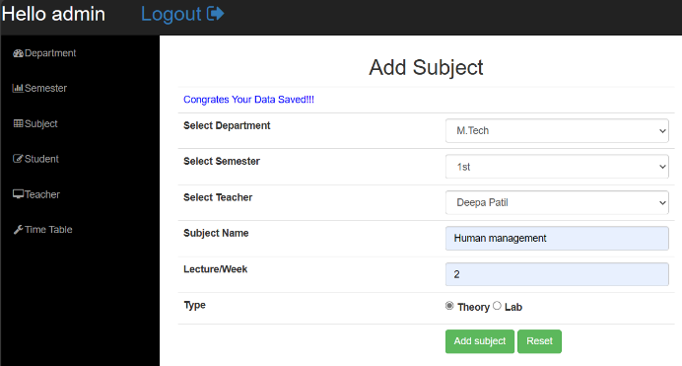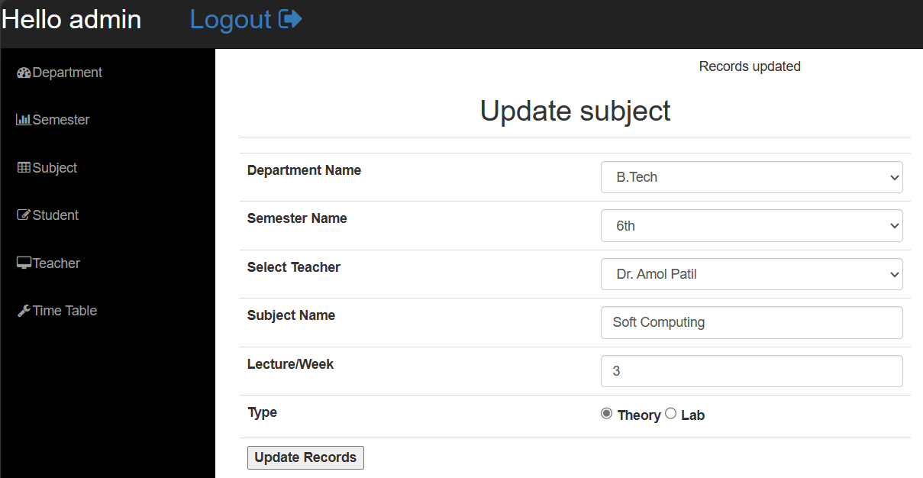

### Add Student

**Path:** Home/Admin/Student

**Description:** Form to add new student in the database

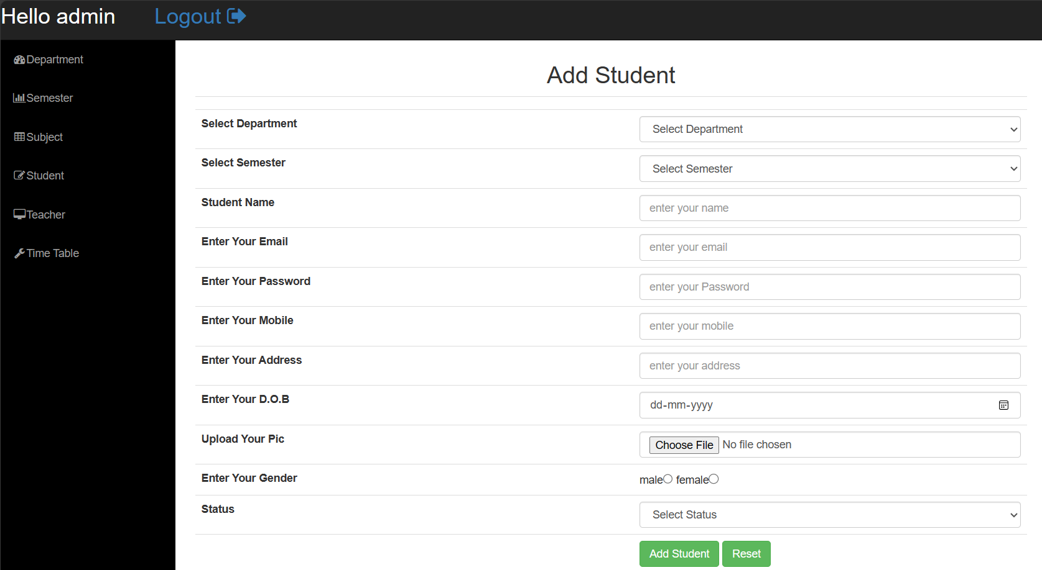

### Validation:

Alert on successful submission of data

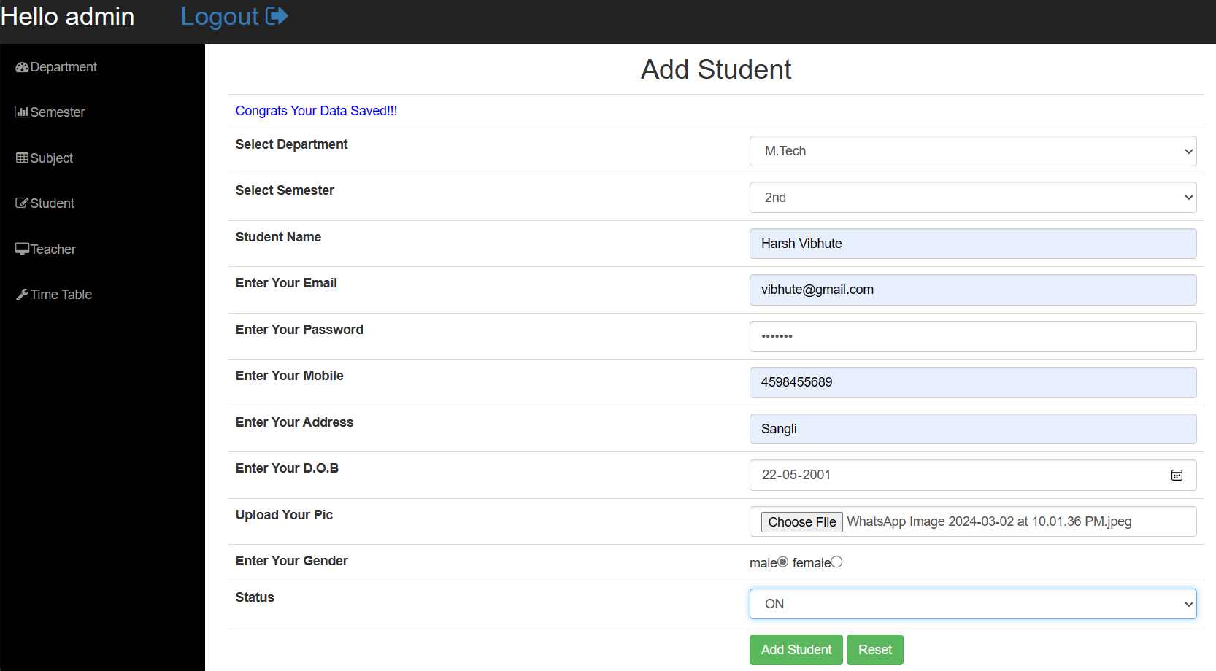

### Student Update

**Path:** Home/Admin/Student

**Description:**

To update existing students profile

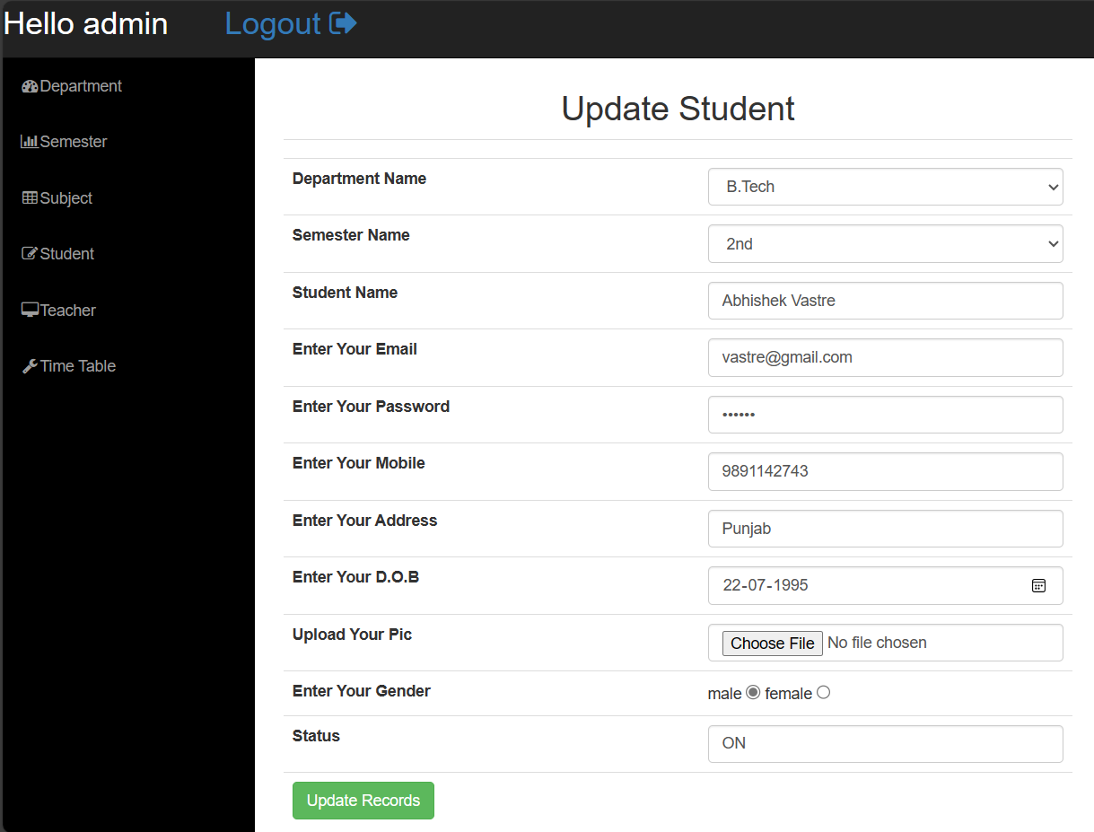

### Validation:

Alert on successful submission of data

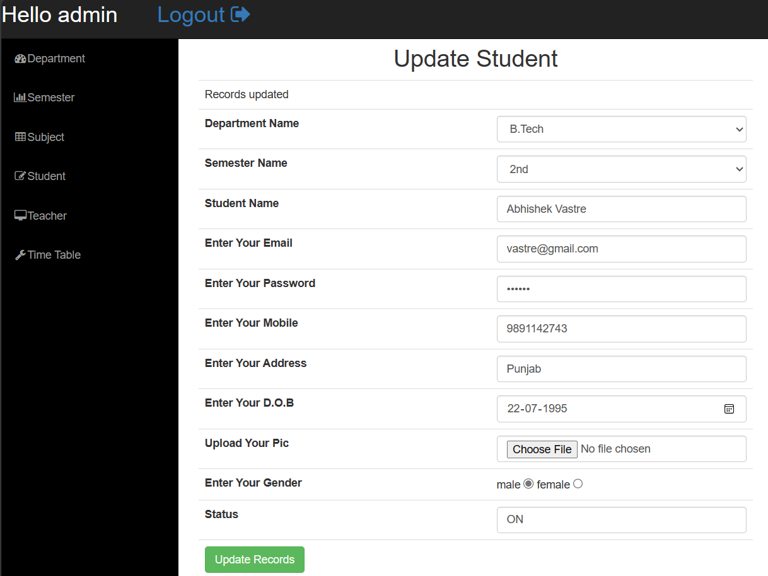

### Add Teacher

**Path:** Home/Admin/Teacher

**Description:** To add new teacher/staff on the database

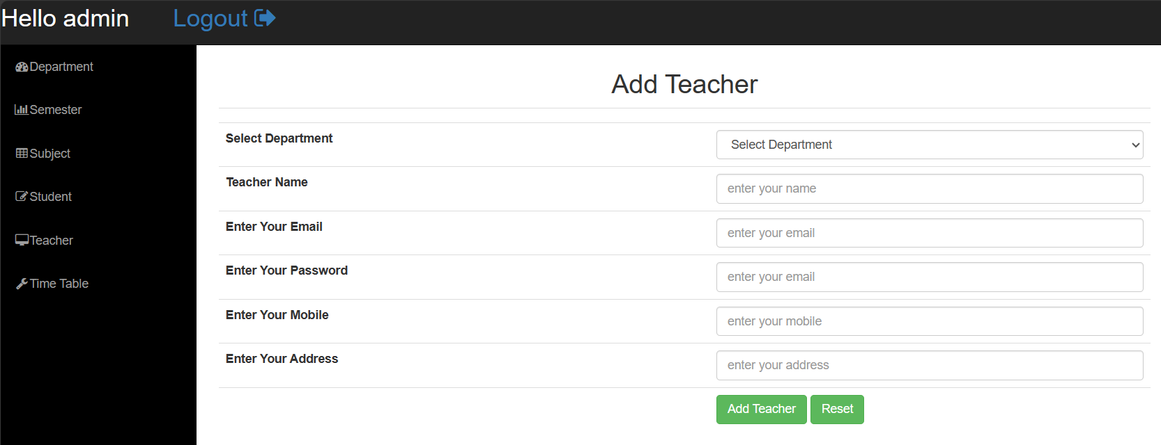

### Validation:

### Alert for required field and also check if teacher/staff already exist

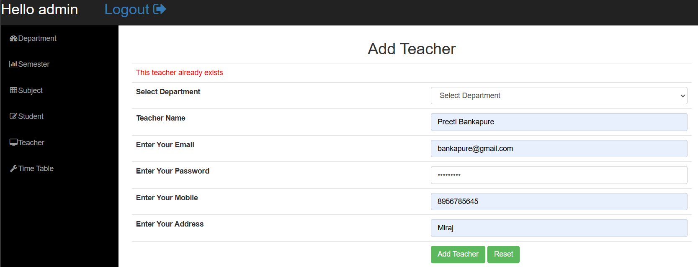

### Update Teacher

**Path:** Home/Admin/Teacher

**Description:** To update teacher/staff’s profile

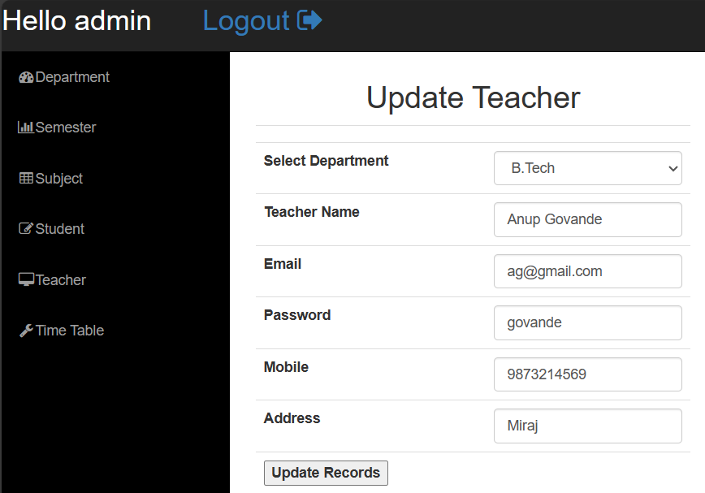

### Validation:

### Alert on successful submission of data

### 

### Time Table

**Path:** Home/Admin/Time Table

**Description:** To generate time table according to lectures count

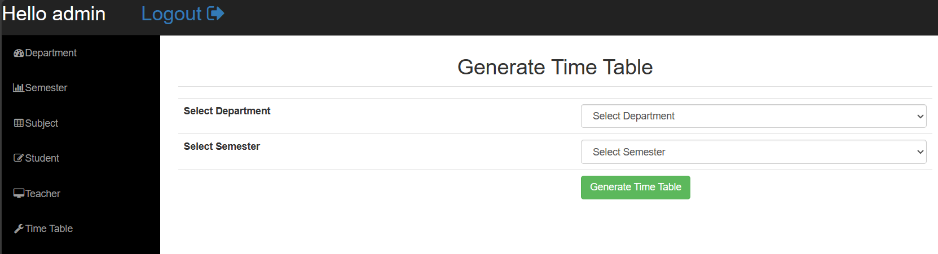

### Validation: If lectures are present then schedule them accordingly

### 

### Change Password

**Path:** Home/Staff/Change Password - Home/Student/Change Password

**Description:** To change existing password of staff/student

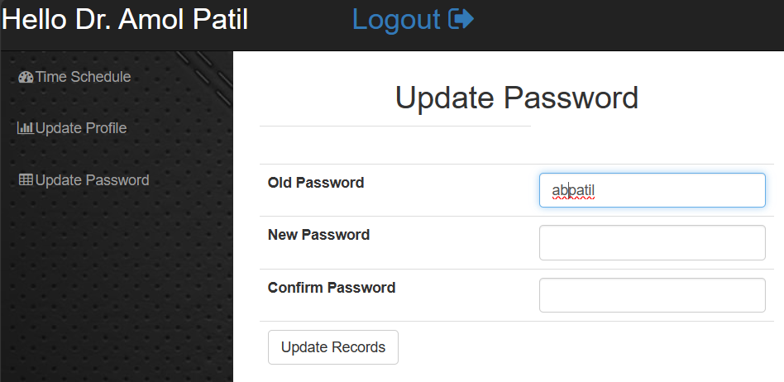

**Validate:**

Alert on successful submission

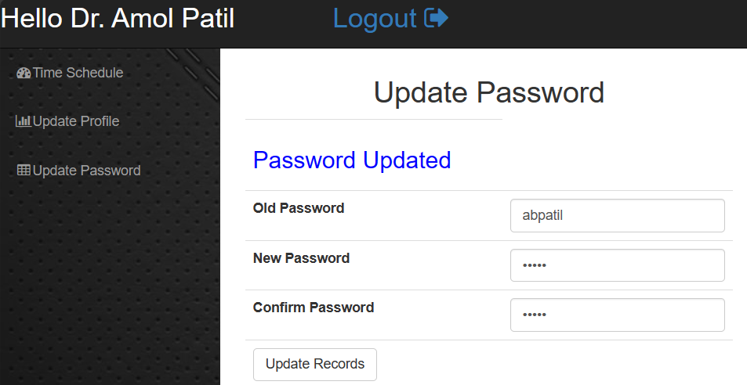

## Output Design

* **Home**

**Path :** Home

**Description :** Default landing page called home

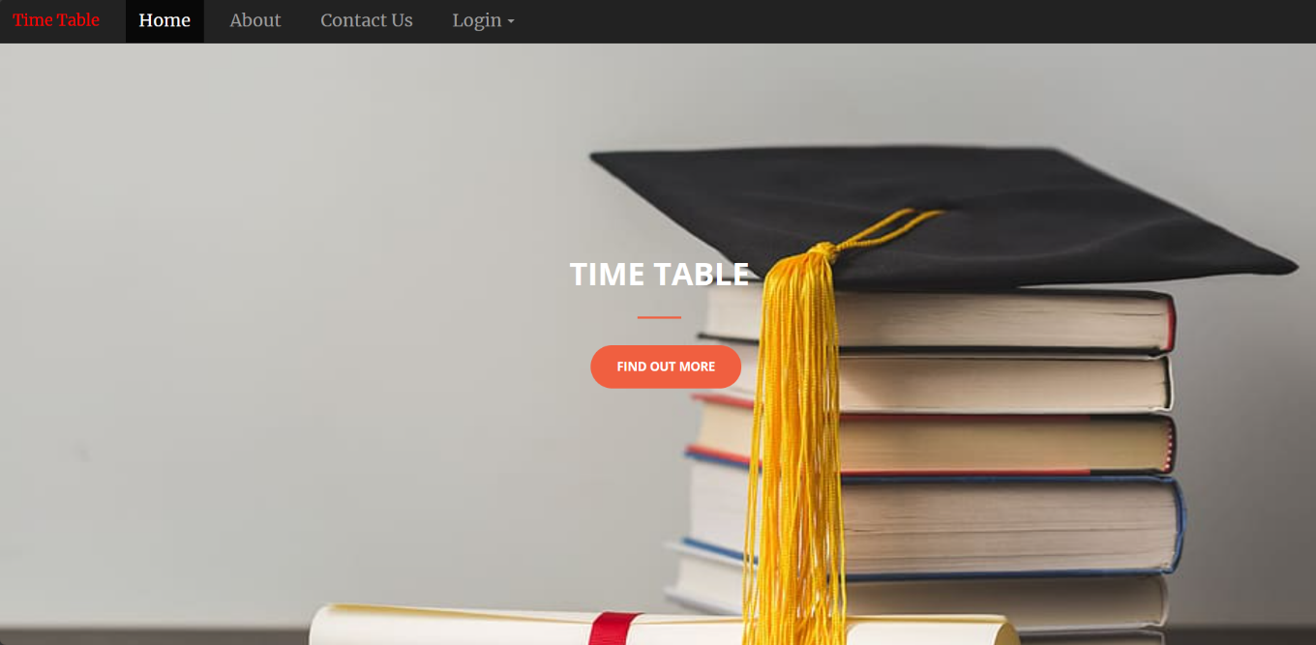

* **About**

**Path :** Home/About

**Description :** To show about us detail

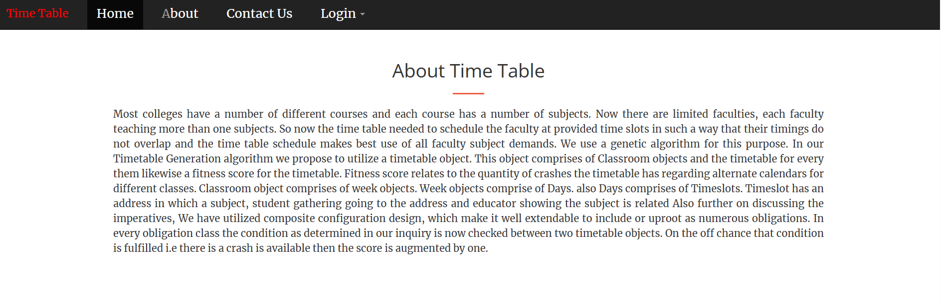

* **About**

**Path :** Home/Admin Home

**Description :** Home page shown after admin login

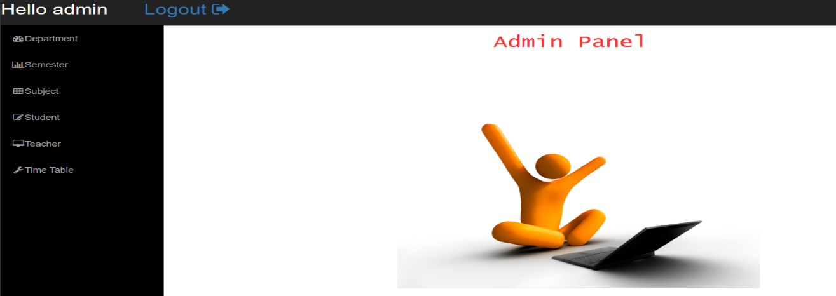

* **Student Home**

**Path :** Home/Staff Home

**Description :** Home page shown after Staff login

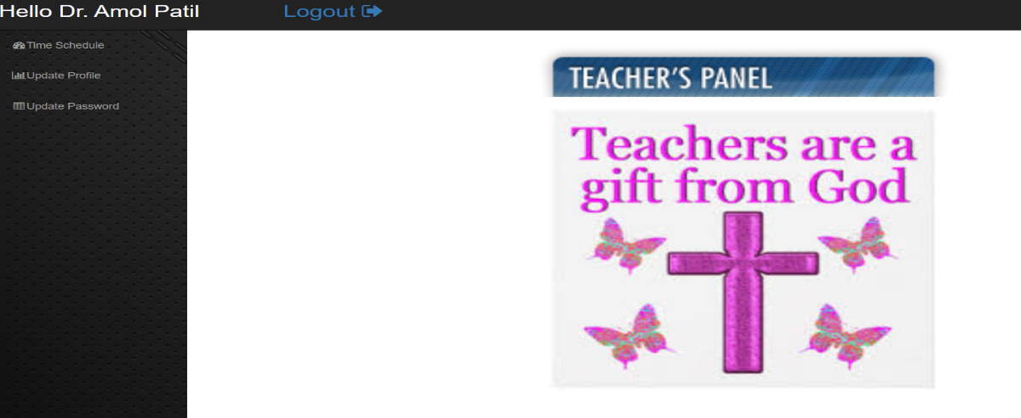

* **Student Home**

**Path :** Home/Student Home

**Description :** Home page shown after Student login

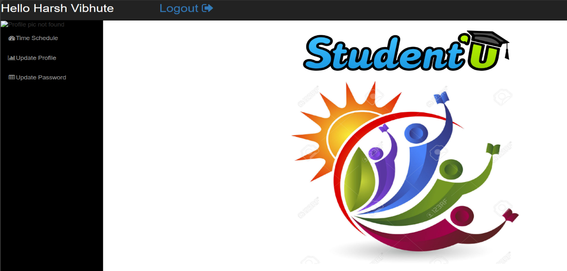

**5. Implementation**

**5.1 Software Requirements :**

* + **Operating System** :- Microsoft Windows XP/NT Windows 7 & above
  + **Web Browser** :- Internet Explorer, Google Chrome, etc
  + **Front end** :- HTML, CSS & PHP
  + **Back end** :- PHP
  + **Web Server** :- Xampp (apache)

**5.2 Hardware Requirements :**

* + **Processor** :Pentium 4 & above
  + **Ram** :8GB & above
  + **Hard Disc Space** :1TB & above
  + **Printer** :Dot Matrix/ ink jet
  + **Display Unit** :Monitor or LCD

**Installation Process :**

XAMPP is a compilation of free software, with each letter representing a key component. It includes the Apache web server, the MySQL or MariaDB relational database management system, and the scripting languages Perl and PHP. The "X" in XAMPP stands for the operating systems it supports: Linux, Windows, and macOS.

**Apache:**

Apache is an open-source web server widely used globally for delivering web content. It is provided as free software by the Apache Software Foundation.

**MySQL/MariaDB:**

XAMPP includes MySQL, one of the most popular relational database management systems. Recent versions have replaced MySQL with MariaDB, a community-developed fork of the MySQL project.

**PHP:**

PHP is a server-side programming language that allows users to create dynamic websites or applications. It can be installed on various platforms and supports diverse database systems.

**Perl:**

Perl, a scripting language, finds applications in system administration, web development, and network programming. Similar to PHP, Perl enables users to program dynamic web applications.

**Steps in Installation :**

**Installing XAMPP:**

**Step 1:**

Download XAMPP Download the XAMPP release from the Apache Friends website. Versions with PHP 5.5, 5.6, or 7 are available.

**Step 2:**

Run .exe file Double-click the downloaded .exe file to start the installation process.

**Step 3:**

Deactivate Antivirus Software Temporarily disable antivirus software as it can interfere with the installation.

**Step 4:**

Deactivate UAC Turn off User Account Control (UAC) temporarily, as it can limit writing access to the C: drive.

**Step 5:**

Start the Setup Wizard Open the .exe file, following the deactivation of antivirus software and UAC. The XAMPP setup wizard should appear. Click 'Next' to configure installation settings.

**Step 6:**

Choose Software Components Under 'Select Components,' choose components for the XAMPP installation. For a complete local test server, the standard setup with all components is recommended.

**Step 7:**

Choose the Installation Directory Select the installation directory for the XAMPP software packet. Opt for the standard setup if unsure.

**6. Reports**

* **Department**

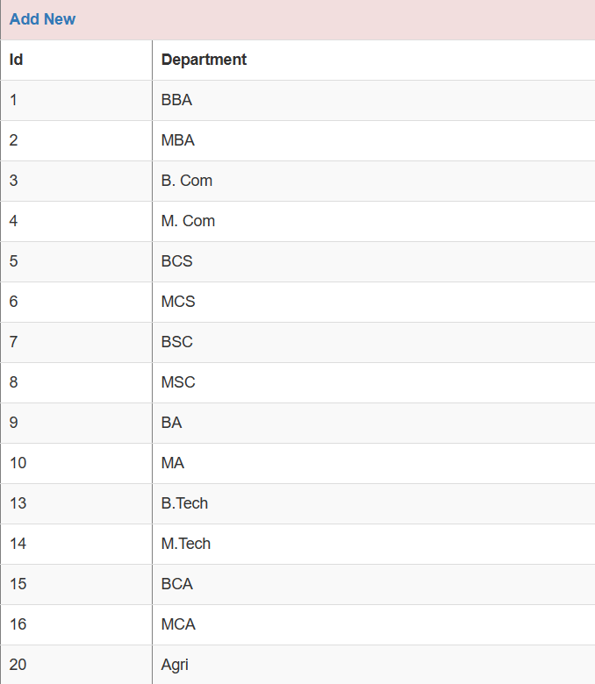

* **Semester**

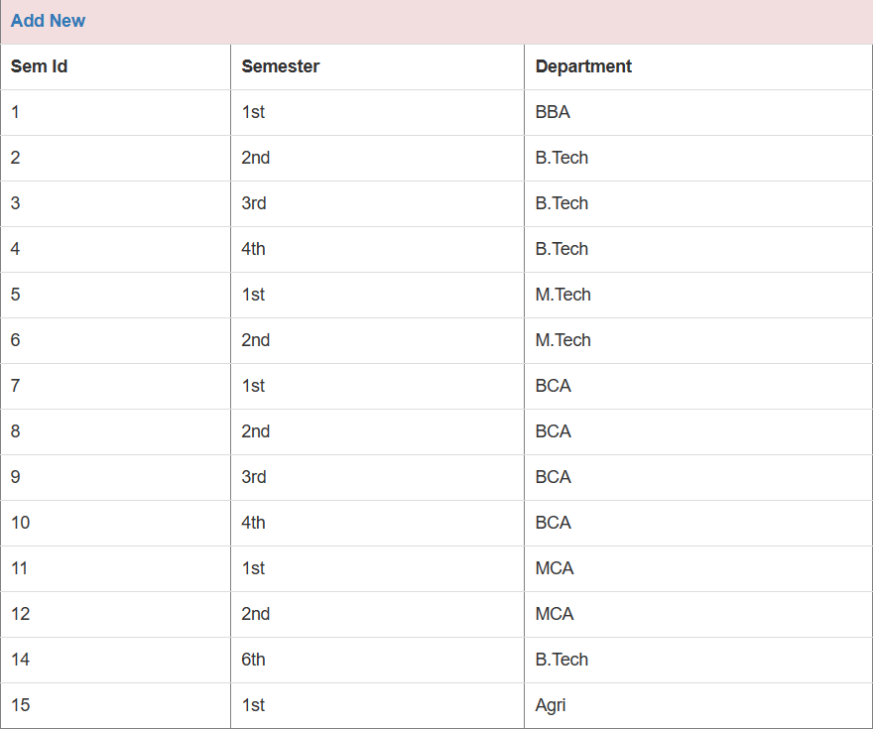

* **Subject (For department B.tech)**

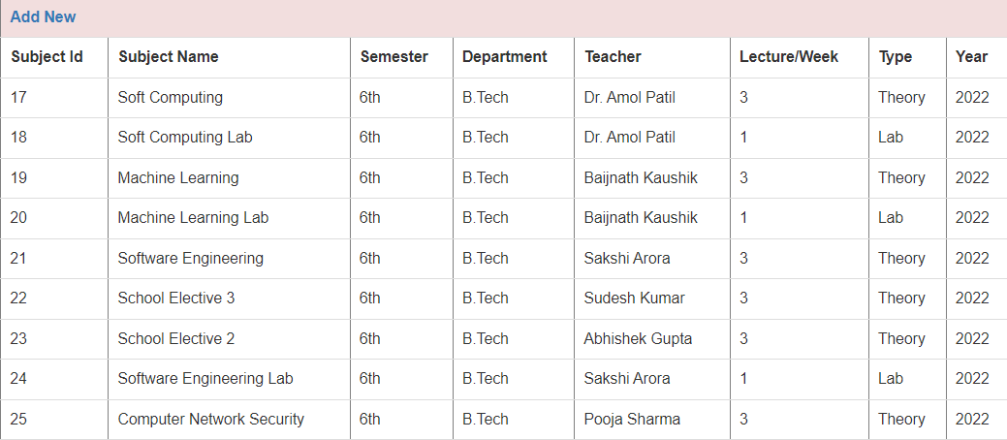

* **Time Table (For department B.tech)**

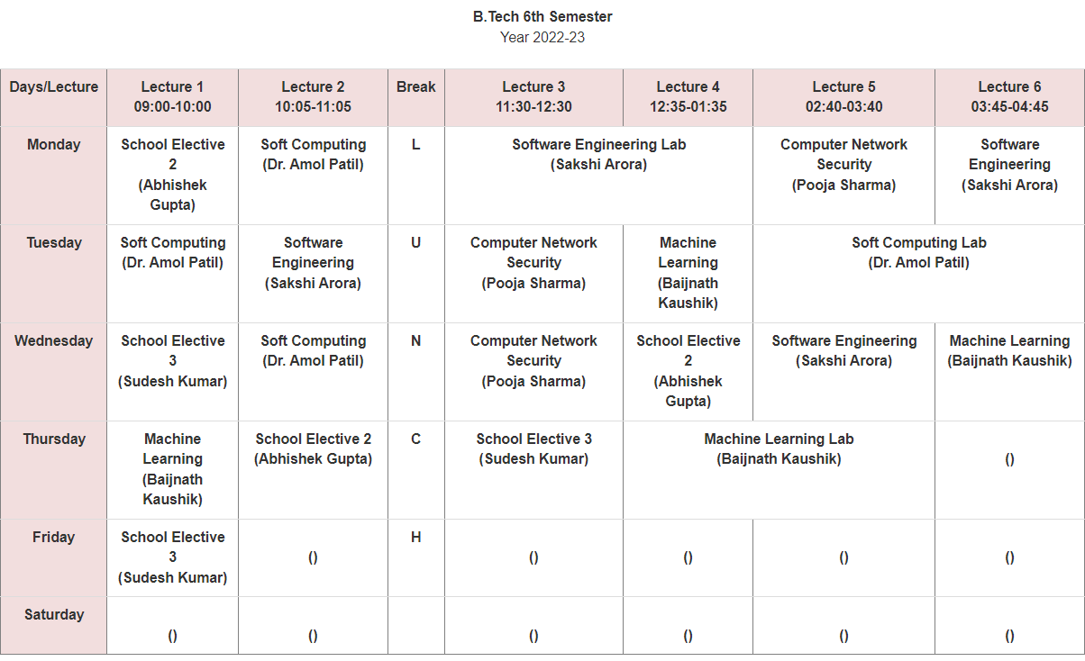

* **Teacher**

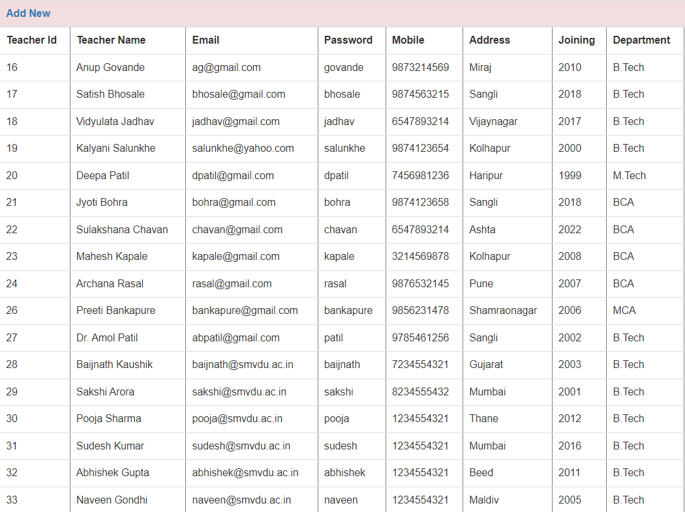

* **Student**

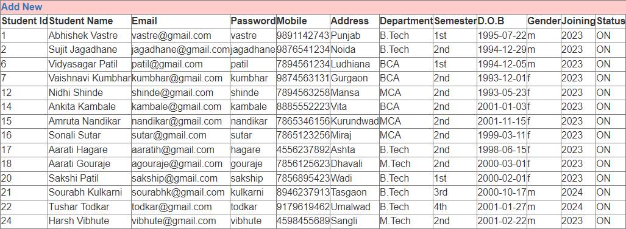

**7. Conclusion & Suggestion**

## Limitations

* + - Lecture adjustment is complex in current phase
    - Generated timetable can’t be printed
    - Cannot provide the verification code at the login page
    - No notifications for teacher and student
    - Admin handle most of the rights

## Suggestions (Future Enhancement)

* + - Lecture adjustment should be made simpler for off lecture and overlapped lecture
    - Making generated timetable’s print on one click.
    - Use verification code at the time of accessing site
    - Sending notifications to both student and teacher
    - Giving necessary rights to teacher and students
  1. **Conclusion**

In conclusion, the Time Table Generator system offers a promising solution to streamline lecture timetable scheduling in educational institutions. While the system presents numerous benefits, including automation, efficiency improvements, and enhanced user experience, it also faces limitations and challenges that must be addressed for successful implementation.

By carefully considering the limitations and implementing suggested strategies, stakeholders can maximize the system's potential and achieve its intended goals of optimizing resource allocation, minimizing scheduling conflicts, and improving overall operational efficiency within the educational institution. With proper planning, support, and collaboration, the Time Table Generator system can make a significant positive impact on scheduling processes and academic operations.

**8. References**

## Books

* + - None

## Web

* + - [www.w3schools.com](http://www.w3schools.com/) (For CSS implementation)
    - [**https://getbootstrap.com**](https://getbootstrap.com/)(For CSS implementation)